Lab 13: Templates, Inheritance, Friends
Covering Lectures: Lectures 37 - 38
Objective:
This Lab aims to give students a deep understanding of the basic use of
- Templates and Inheritance in C++
- Templates and Friends in C++
Learning Outcomes:
After completing this lab, students can practice different types of templates with the inheritance and Friends.
Part a.
Problem Statement:
Write a C++ code for a template-based class Shape with two derived classes Rectangle and Circle. Derived classes are also template classes.
- Define a base class Shape with a pure virtual function getArea() to calculate the area.
- Define two derived classes:
  - Rectangle that calculates the area of a rectangle (length * width).
  - Circle that calculates the area of a circle (π * radius^2).
- Write a main function that:
  - Creates two instances of Rectangle class with double and integer datatypes.
  - Creates two instances of Circle class with double and integer datatypes.
  - Call the getArea() function with all the instances of both classes as per the sample output.
Sample Output:
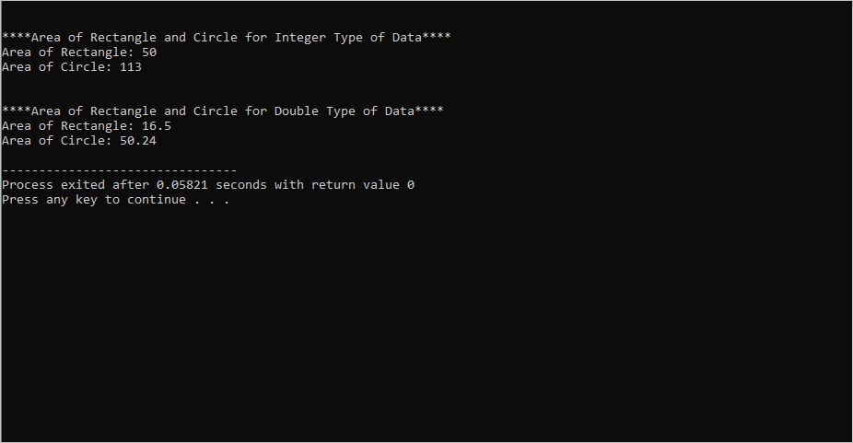
Part b.
Problem Statement:
Write C++ code for the following template readData and Subtract classes.
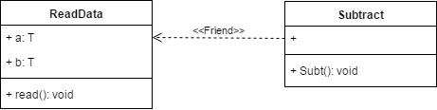
Subtract class is the friend of the ReadData class and can access the private data members of the Subtract class.
The read() method of the Subtract class takes input from the user for both data members.
In the Subt() function create two objects of ReadData for int and float, perform subtraction on the data for both objects, and print the result for each datatype.
Sample Output:
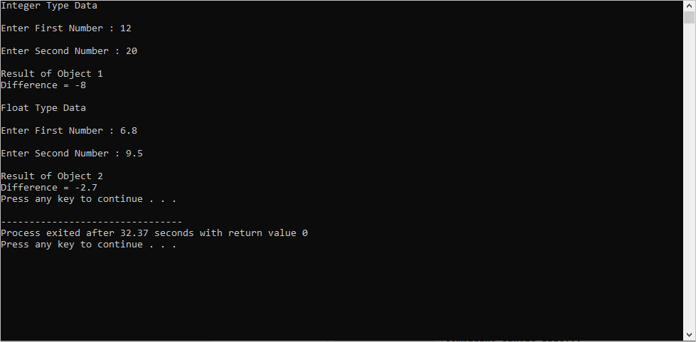
Practice Questions:
- Question 1: Write a C++ code
  - for a non-template class Color with data member mcolor and getter() and setter() functions. The setter() function will set the mcolor value. The getter() function will return the name of the color.
  - For a template class Circle inherited from the class Color. The Circle class has data member radius.
  - In the mian () function create the objects of class Cirle for int and double datatypes and set the values of radius and color. Display the values of both variables using the Circle class objects.
- Question 2: You are working on a banking system that manages various bank accounts (e.g., savings, checking, etc.). Create a template class Account<T> to store account details, where T can represent different currencies (like USD, EUR). Also, create a BankManager class to manage accounts in any currency and modify account balances.
Requirements:
  - Use templates to define the Account<T> class.
  - The BankManager class should access and modify the balance of any Account<T> object, no matter what type T is.
  - The BankManager class should be a friend of Account<T>.

